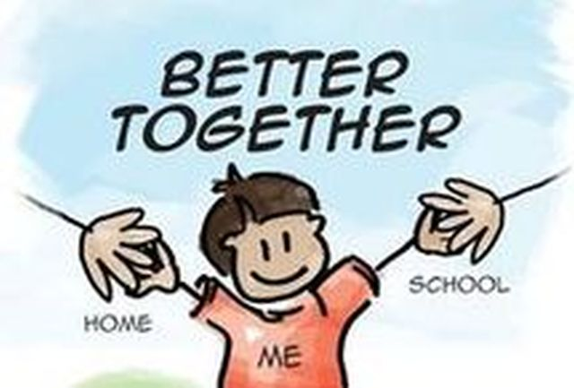
Parents’ Booklet
Ways to support your
Year Two Child
at Home
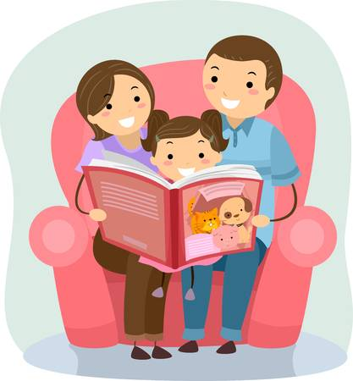
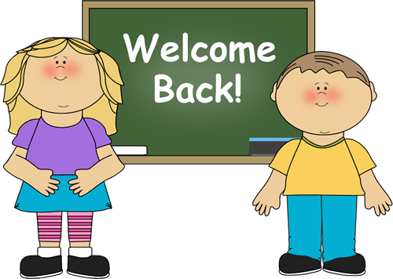
A warm welcome back to Year 2 parents and children!

We are all so thankful to welcome all our Year 2 children back to school, after what has been a challenging and anxious time for us all. We continue to pray for an end to Covid-19. In the meantime, our aim is to make this transition from Year 1 to Year 2 as smooth as possible for our young children. For many this may be a challenging experience. Our children have been used to the company of mainly family members in recent months and now they are re-entering into school, with many new changes, routines and rules to follow, in order to keep everyone safe and healthy.

It may take your child a little while to settle back into school – please don’t worry at this time as this is understandable, considering the events of recent months. Please feel reassured that we will do our very best to continue to keep your child safe and happy in school, whilst continuing to progress through the Year 2 curriculum.

As we are sure you will understand, our main priority this first term will be to ensure your child has settled happily back into school, gaining knowledge of some changes in routine and rules, learning about the importance of personal hygiene and lots of revision of previous learning. Mrs Taggart will carry out some baseline assessments with the Year 2 children during the first few weeks.

Children should look forward to coming to school and we ask you to emphasize the enjoyment to be had at school and the interesting activities that they will experience. Success in school depends greatly on co-operation and trust between home and school. You as a parent have an important role to play. Your child needs interest, your time, praise and encouragement.

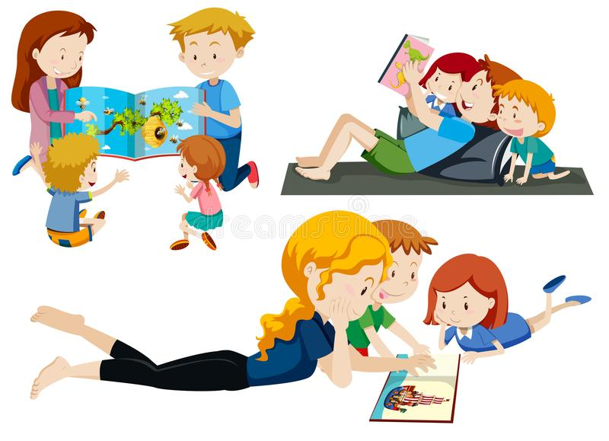

Please read the important information in this booklet, as we begin the new term.

- Staggered Drop off Times – Year 2 children are asked to be dropped off at the gate at 9.00am sharp.
If they have an older sibling, they must be dropped off at their allocated ‘drop-off’ time. Please leave your child at the school gate. Due to Covid-19 restrictions, parents are not permitted on school grounds, unless by appointment.

- Pick up routine – Please wait outside the school gate, where your child will be brought to you, by Mrs Taggart or Mrs Mulryan.

- Early Pick-up - If your child is leaving school early please give advanced notice by ringing and leaving a message with the school office.

- Any changes to pick-up arrangements, relating to Eskra Playtime after-schools, parents MUST notify both school and after schools of this, to avoid any unnecessary confusion for all relevant staff and your child.

- No rucksacks are permitted in school. If your child is going to after schools and requires a change of clothes, please leave this bag/rucksack over in after schools in the morning.

- Due to Covid-19 restrictions, unfortunately, we have made the decision that Claude will remain in school for the foreseeable. The children will continue to have lots of fun with our little French friend in class, where Claude will help Mrs Taggart teach the children all about their new rules and routines. When your child is announced as ‘Pupil of the Week’ this year, we ask that they choose their favourite soft toy from home to enjoy a special weekend treat with. We ask that parents take one or 2 pictures of this special time and send the photos into school. We will create a unique memory scrapbook this year called ‘Friends of Claude – Special Edition’!!!

- Children are asked to wear their P.E uniform each Friday, beginning Friday 4th September. Full uniform is expected Monday – Thursday.

- Care of Clothing - Please label all items of clothing and child’s belongings; ties, jumpers, coats, hats, gloves, lunch-bags, etc.
We recommend that you wash your child’s uniform and lunch-bag every day.

- In the interests of hygiene, please send your child’s snack in a plastic sandwich bag and leave in their red reading bag, to help with their organisational skills and to allow for a smoother snack routine.

- The children will wash and sanitise their hands at various times throughout the school day. We ask that you encourage this at home. Please refer to September Newsletter.

- The resources used during play based learning in Year 2 will be limited. Toys etc, used during play, will be cleaned and sanitised every day.

- Homework will remain as before. We ask that you help your child complete their homework to the best of their ability, spend some quality time each night, as opposed to completing all homework activities on one night. Pay particular attention also to neat presentation and finish of their homework, focussing on correct letter and number formation, adding detail to any drawings etc. Your Year 2 child will receive a ‘Tricky Word’ workbook, along with their reading book, during the month of September. Further details will follow.

- Say your prayers daily with your child. Can they bless themselves?

- Set up some ‘Golden Rules’ in your home. Talk to your child about the importance of rules and why they are important in keeping us safe and happy.

- Talk to your child about the importance of taking responsibility for their actions and the importance of showing respect, politeness, kindness, friendship to others.

- Talk to your child about resilience. Especially in this world our young people are growing up in, they need to be able to understand that things are not always going to go the way they had hoped and they need to be taught and learn coping strategies they can use to become more resilient against defeat or how they can use a mistake to help them improve.

Our Class Motto in Year 2 is “Have a go!”

Language and Literacy in Year 2

Literacy focuses on developing each child’s ability to understand and use language as an integral part of learning in all areas. Children need to interact effectively in the world around them, to express themselves creatively, to progress their learning of the wider curriculum and to communicate confidently using the four modes of language: talking and listening, reading and writing.
The development of effective language and literacy is crucial to living and learning.
Language is used to communicate with people, to share and express feelings, to give and obtain information and understand ideas and develop thoughts. Children bring to school their own experiences of using language, both oral and written, in the home, preschool settings and local community. Children’s language and literacy experiences should take place within a rich and stimulating environment. In Year 2 we are encouraging interaction and the promotion of communication as a tool for learning.
We observe children’s progress and use the information gathered to plan future learning experiences to develop effective talking, listening, reading and writing.

Talking and Listening:
How can you help?
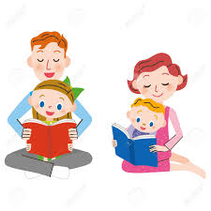
You can help to improve your child’s talking and listening skills at home:
• Talk to your child to develop oral skills and vocabulary.
• Read and say nursery rhymes to develop rhyme awareness.
• Discuss interesting news stories with your child.
• Limit T.V to encourage more social interaction for your child.
• Discuss books / shows / outings with the children – this will help them to form opinions and will develop their oral communication skills.
• Play commercial listening games – Early Learning Centre has excellent resources.
• Go on nature walks and listen to natural sounds in our environment.
• Play games e.g. “I spy”, “I went to the market” and “Simon Says” etc.
• Visit bookshops and libraries and encourage your child to be interested in books and to talk about authors / characters / plots etc.

Reading in Year 2:

Children should be encouraged to develop a love of books and the disposition to read. As stories are read to them children should see the reader as a role model. They should listen to a range of interesting and exciting fiction, non-fiction, poetry and rhymes, retell familiar stories and share a wide range of books with adults and other children.
As children begin to understand that print carries meaning they should also be encouraged to develop a curiosity about words, how they sound, the patterns within words and how they are composed.

**Reading experiences should be relaxed and enjoyable. **

While the central purpose of reading is to gain meaning from print, children also need to be encouraged to develop a curiosity about words, their sounds, and patterns and how they are composed.

We need to establish a language-rich environment and model and share reading with the children, demonstrating that it is an active part in the process of constructing meaning.

As a parent you are probably helping your child to be a proficient reader much more than you realise. Your home contains books, newspapers, magazines and catalogues and your child sees you reading and using printed materials to find things out e.g. in a catalogue, dictionary and menus on a regular basis. From early on your child becomes subconsciously aware of the importance of being able to read.

In Year 2 your child learns to read through:
• Shared reading
• Guided reading
• Independent reading
• Story time – led by the teacher.

Your child will be learning to read through a range of reading schemes, including the Sounds-Write reading scheme and New Way reading scheme.
Your child will bring home their ‘reading book’ on a Monday night.

How can you help?
• Take a picture walk through stories discussing pictures and what the story may be about. Give time to discuss the book. Concentrate on enjoyment.

**Keep the experience relaxed, quiet and with the
TV turned off.**

• Talk about the cover and read the title. Ask questions such as “What do you think the book will be about?”, “What sort of book is it?”, “Have you read a book like this before or by this author?”
• Look through it together noticing its pictures, characters’ names and any difficult words.
• Encourage your child to track – sound out each word one by one (reinforce left to right directionality of text and use a “reading finger” if necessary)
• Let your child try to work out TRICKY words by searching the picture for a clue, sounding out the letters of the word to try and BLEND together or reading around the text to help them predict what the word may be. Tell your child the word if they become frustrated.
• Support your child in learning to read his/her ‘Tricky Words’ each night.
• Support your child in their Shared Reading homework each Thursday evening.
• Ask your child to retell the story or a favourite section.
• Stay calm and positive when your child is reading.
• Look out for book events in bookshops or story telling sessions in your local library.
• Buy books for birthday and Christmas presents.

***Praise your child for trying and having a go!***

Writing in Year 2

In Year 2 children are given opportunities to experiment with their own written communication for their own purposes, using a range of writing materials such as pens, pencils, crayons and paint. They have opportunities to ‘read’ their own writing and know their writing is valued.
As children begin to write with more competence they are helped to express their ideas clearly using their increasing vocabulary and knowledge of sentence structure. We provide specific modelling of the writing process through a range of writing forms for different purposes and audiences.
Children have access to a stimulating writing area with a variety of tools and media throughout the school day and are encouraged to ‘write’ during play and in every curricular area.

How can you help?
• Be a writing model and encourage your child to write alongside you e.g. shopping lists, notes and birthday cards.
• Let your child write for real e.g. thank you letters, a get well card, postcards while on holiday etc
• Talk to your child about the writing he/she has done in school.
• Keep a selection of paper, felt tip pens, biros available.
• Support your child in learning his/her spellings each night. (this is applicable later in the year).
• Don’t criticise your child’s mistakes – praise and encourage all efforts: Remember our Class Motto is “Have a Go!!!”

Mathematics in Year 2
We use maths every day. For example, planning what to watch on TV, measuring, cooking, shopping and telling the time. Make the most of the opportunities that these everyday tasks present in terms of making maths
useful, real and most of all fun for your child!
Be positive. Celebrate the maths your child can do.
Maths is not always about being right or wrong! Can your child, explain their thinking when working things out.? Don’t panic if your child does their maths a different way!
You don’t have to be great at maths to help your child. You don’t have to know all the answers either!
As your child will have worked hard at school, remember to stop when he/she may begin to lose interest.
Try to work with your child when neither of you are tired
or stressed, otherwise you may do more harm than good! You don’t need much time…just a few minutes will do.
If your way of working out something is different from your child’s, allow your child to explain the method the teacher has taught. If in any doubt, talk to your child’s teacher so that your child does not become confused.
Encourage your child to ‘have a go’. Remember our class motto is ‘Have a Go’! Resist the temptation to tell your child the answer as it is better to coax a response / help your child work through the answer.

Shopping

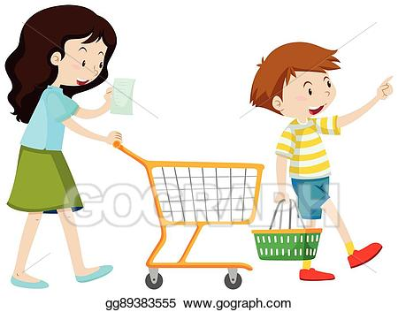
Before you go out you might:
• Talk about where you keep money safe e.g. purse or wallet.
• Discuss how you will pay for your shopping e.g. using cash, debit/credit card.
• Write a shopping list.
• Talk about how many bags you may need to pack the shopping.
• Plan the order of the shops you are going to visit - what needs to be bought first?
• Talk about the route to the supermarket or directions for finding the aisle.

In the shop you might:
• Find the item you are looking for and talk about where it was found e.g. is it “next to”, “beside”, “above”, or “below” another item. Can you reach it? What is the aisle number?
•Talk about the best way to buy a number of similar items, for example, yoghurts/crisps. Is it better to buy a pack of six or six individual items? Compare the cost per item on the shelf label.
• Look at the price of an item. Discuss if you have enough money to pay for it and if it is good value.
• Take time to discuss special offers re: price and weight, for example, 3 for the price of 2, Buy one get one free.
• Count loose items of fruit and put in a bag.
• Check off the items on your shopping list.
• Talk about the total number or cost of items purchased.
• Talk about the change you got and why.

Back at home you might:
• Ask your child which bag of shopping is the heaviest? Which items make it the heaviest? Which is the lightest?
• Use the bathroom scales to weigh a bag of shopping.
• Encourage your child to unpack and check the items purchased against the receipt.
• Sort the items that go into the fridge, freezer, different cupboards or rooms.
• Look at the size and shape of packaging and talk about how to arrange it in the cupboard/fridge/freezer.

Money
You can help your child;
• Recognise and name coins.
• Sort coins, colour, size, sterling, euro, etc.
• Count in ones (1p coins, £1 coins).
• Count the amount of money in the purse.
• Tell you what coins they need to pay for an item.
• Play shopping activities where children need to give the correct coins to receive the goods or the change required if they are the shop keeper.
• Be aware of how many 1p coins makes 10p.
• Save on a regular basis e.g. a money box or savings account.
• Budget their pocket money for a period of time.

In the Kitchen
• Use foods such as fruit, pizza, cake, bread and chocolate to discuss:
- shapes such as squares, triangles or rectangles.
- fractions such as halves and quarters.
• Allow your child to weigh ingredients when following a recipe or instructions on a packet.
• Look for numbers: on the microwave, oven, clock, calendar, kettle, scales
• Talk about the patterns on the tiles, floor, curtains, wallpaper. Look for shapes and repeated patterns.
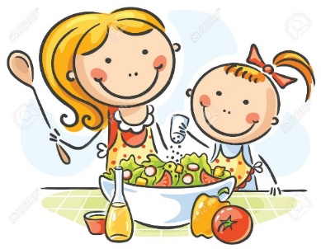
• Fill containers and help your child talk about whether they are empty or full. Order containers according to size.
• Talk about the capacity and shapes of different containers.
• Look at how much milk is in the fridge. Is there enough for breakfast tomorrow morning?

In the Garden and Street
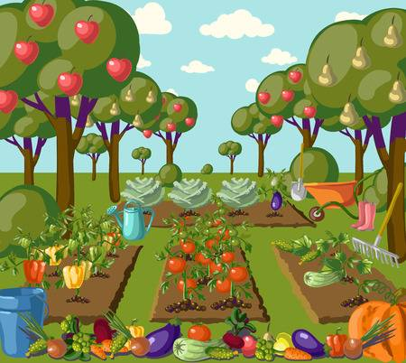
• Talk about shapes that you see on the roof of your house, windows, doors, pathways, oil tank.
• Look for patterns in the path, fence, wall, windows, flowers.
• Compare the tallest/smallest flowers.
• Talk about the purposes of banks and post offices.
• Look at how houses in your street are numbered...Can they spot a pattern?
• Identify numbers in car registration plates.

Play Maths Games
• Games are fun and give children a positive and enjoyable attitude towards maths!
• Games allow children to practise simple maths strategies such as counting, counting on etc.
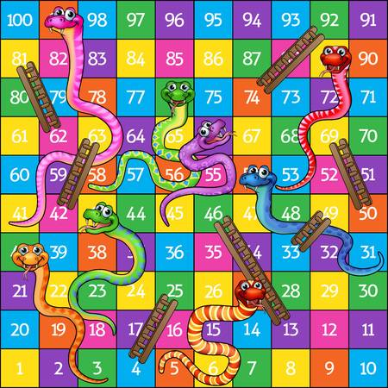
• Board games can foster the ability to focus and may help increase your child’s attention span and concentration.
• Games like Snake and Ladders demonstrate that, just as in life, your luck can change in an instant for better or worse!
• Playing board games can help children to think logically whilst teaching them about taking turns and following rules.

Research indicates that playing games once or twice a week can improve your child’s maths skills.

Time
Time is about more than just telling the time on a clock! It is a very difficult area for children to understand, but there are plenty of ways that you can help at home.

Events of the day
• Discuss the events of the day: first we get washed, then we get dressed and then we eat our breakfast…go to school…etc
• Talk about what happens in morning, afternoon and evening.
• In the morning, ask what will we do first e.g. Brush our teeth or go to school?
• When getting dressed, ask which clothes will we put on first e.g. socks or
T-shirt.
• Talk about “yesterday” or “tomorrow” to provide solid milestones for your child.

Days of the week
• Talk about what day it is and what you are going to do.
• Which days they go to school or stay at home.
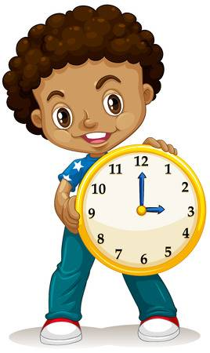
• Discuss what day it is and how many days are in a week. Count down the number of days or weeks until a special event.
• Use stickers or simple weather symbols to track the weather and talk about this at the end of each week/month.

Telling the time
• Look at the clock at specific times e.g. Time for school/bed.
• Together look up the time of a television programme that they want to watch (how long until it begins, how long does it last? What channel is it on?)

Passage of time
• To understand that some activities take longer than others begin to make comparisons and see which takes longer e.g. Set the table or tidy your room.
• Carry out simple activities to compare how long it takes e.g. Who can stand on one foot longer?
• Set time limits – Play for 5/10 more minutes and then you must come in for lunch (Initially your child will not understand minutes but gradually they will understand the idea of time passing).
• Estimate how long it takes to drive/walk to school. Check this with the correct time. This will help to develop a sense for the passage of time.
• Use a timer/count slowly to play ‘Beat the clock!’, if they get ready for bed in 2 minutes/slowly count to 30, they will get an extra bedtime story.
• Plant seeds and see how long it takes for them to grow e.g. Cress seeds (short time), crocus bulbs (longer time).

We hope you find this information useful and we look forward to the new school year ahead.

Kind Regards

Mrs C. Taggart Mrs T. Mulryan
Year 1 & 2 Class Teacher Year 1 & 2 Classroom Assistant

